3GPP TSG-RAN WG1 Meeting #83 R1-157777
Anaheim, USA, 15th - 22nd November 2015
Source: ZTE
Title: Enhancement of resource allocation and procedure for V2V
Agenda Item: 6.2.8.1.1
Document for: Discussion

Introduction
In RAN1 #82bis chairman’s notes, the resource allocation principles listed below should be studied for PC5-based V2V (note that other schemes are not precluded):
  - Enhancement to resource selection/structure
    - Study which of the following principle(s) is(are) beneficial:
    - Collision avoidance
      - A UE identifies the resources that will be occupied and/or collided by the other UEs and avoids a colliding resource allocation for its transmission.
      - FFS
        - Details of the identification of the occupied and/or collided resources, e.g., by reading other UEs’ SA and/or sensing the energy level
        - How to select the resources and MCS for transmission
        - Whether a UE performs the resource selection procedure for every transmission, and if not, what triggers reselection
          - FFS if the initial selection and reselection procedures are the same or not
        - Whether signaling from eNB (e.g., information on the resource load) or another UE is beneficial.
        - Whether resource in this context is in the physical domain or the logical domain
    - Resource selection based on transmitter-specific information
      - Example 1: Resource allocation based on the location, velocity, and/or direction of the transmitter and/or distance between vehicles.
      - Example 2: A UE reports its observation on the radio environment to help eNB scheduling
    - Enhanced resource randomization
      - Example is increasing the number of time resource patterns.
    - Introducing a finer time resource granularity and/or a coarser frequency resource granularity
    - Semi-persistent scheduling from eNB for PC5 transmissions
    - Cross-carrier scheduling
      - eNB sends control via a carrier to schedule sidelink resource in another carrier not associated with the carrier used for the control transmission.
      - FFS in which scenario(s) this principle is beneficial
In this contribution, some further discussion was addressed on resource selection/allocation enhancement for PC5 based V2V. Also, more evaluation results on the different scenarios of V2X is attached in excel sheet of this contribution. Base on those evaluations, further enhancement for V2X based on existing D2D schemes can be identified.

Enhancement to resource selection/structure

Collision avoidance schemes
In PC5 based V2V communication, one key mechanism of resource allocation is to avoid the resource collision between the vehicle UEs in a certain distance. Based on the enhancement of D2D resource pool structure, the V2V resource pools divides into the SA resource pools and data resource pools. One UE transmits data in data resource pool after sends one or two SAs in SA resource pools. We should consider collision avoidance of data resource by sensing SA with half duplex limitation of SA.
Method 1: Retransmit SA by other UEs or RSU
In D2D communication, SA has transmitted twice in the two subframes calculated by the SA pattern. In V2V communication, as Fig 1 shows, other UEs do the second transmission of SA. In this method, one UE transmit SA in the first subframe as the first step. In the second step, nearby UEs or RSUs nearby UE (e.g. UE1), who correctly received the SA, can retransmit the SA on the second part of SA pool.
After the retransmission by the nearby UEs or RSU, the UEs transmitted first part in the same subframes can know each other’s data assignment. Then, all UEs can know the global data allocated resources. If there are resource collisions between two or more UEs, some of these UE could cancel the data transmission to avoid resource collision. For other UEs, it is also an enhancement on robustness of SA by retransmission.
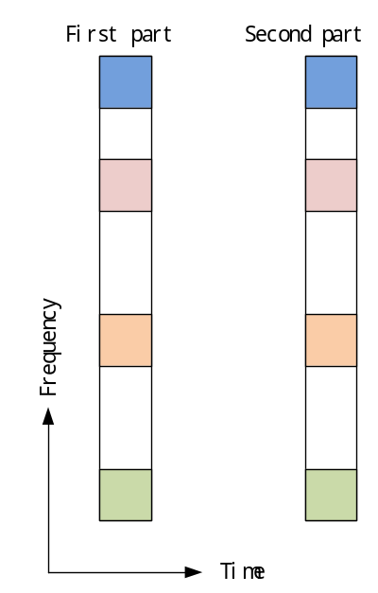
Fig.1 two parts of SA pool

Method 2: UE identifies the resources that will be occupied and/or collided
When a UE has received the SAs of other UEs, it may learn about these SA resources whether be occupied and/or collided by the other UEs or not. So it is useful that a UE identifies the resources that will be occupied and/or collided by the other UEs and avoids a colliding resource allocation for its transmission. As Fig. 2 shown, in subframe index 1, UE3 identifies that UE1 and UE2 have half duplex limitation and need to retransmit SA in different subframes. In subframe index 3, UE2 may identify that UE4 and UE5 have a colliding resource selection/allocation. The context of SA may include the result it’s listening and indicate the collided data resources. It will help the transmitted UE getting the state it had transmitted to choose the retransmit.
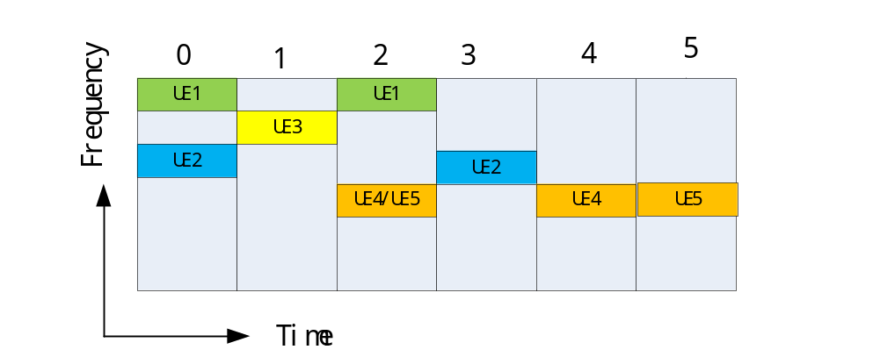
Fig. 2 a sample of SA resource allocation
Method 3: Monitoring other UEs’ SA for certain time before selection SA
In V2V communication, the traffic data always generates in periods. And semi-persistent scheduling could be used for resource selection/allocation. Thus after few SCI periods of data transmission, a UE learn about which resource blocks are free or available to use by reading other UEs’ SA and/or sensing the energy level. Then the UE can choose an available resource to send its data.
Proposal 1: SA retransmitting and SA detecting can be used for Collision avoidance.

Resource selection based on transmitter-specific information
A typical scenario is shown on Fig.3. Mostly, vehicles align with roads, and each vehicle has some characteristics, such as location, velocity, direction, and so on. The vehicles on the same direction lane of the road may have some similar information, such as velocity, direction, etc. The transmitter-specific information can be used to resource selection.
For resource pools selection, one resource pool could be mapped to one direction lane. Then, the vehicle UEs on the same direction lane can be gathered to one group, and may select resources in the same specific resource pool. If UE semi-persistent assign resources, it is helpful when UEs in one group select resources in one resource pool. And for a pedestrian UE, it can save energy that the pedestrian UE can only receive data from the pools which assigned to the vehicles who nearby itself.
For network controlled or assistant resource assignment, a UE reports its observation on the radio environment or its specific information to help eNB scheduling. If a UE reports that there is serious resource collision and the resource pool is crowded for mode2 communication, eNB can assign some UEs to use another resource pool. For mode 1 communication, a UE reports its position that can help eNB to assign its resource to mitigate interference caused by the UEs nearby.
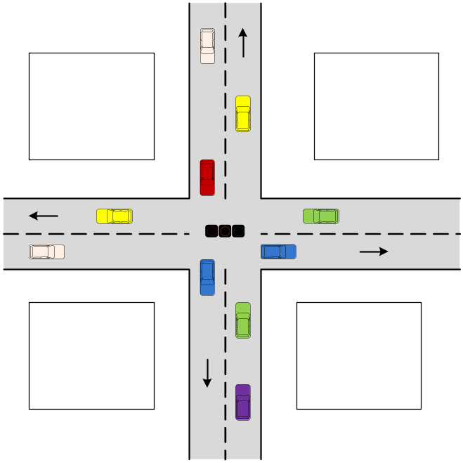
Fig. 3 typical scenario of V2X
Proposal 2: Transmitter-specific information can be used to resource selection, and the detailed parameters are needed to be identified.

Monitoring-based competition on Resource
For V2V scenarios, vehicle UE has higher speed. It can go out of coverage in highway and tunnel. Thus, random selection in resource pools by UE is important in the resource allocation. Even within coverage, random selection resources could save cost of assignment information. In V2V scenario, high density and low latency vehicle communication will result more resource collision in random selection mode. Note that Half duplex D2D scheme will also increase the latency and should be addressed.
Competitive Resource could be introduced. As illustrated in Figure 4, competitive resources are shown. Competitive unit is defined in certain subframe. A competitive unit is orthogonal to others and it corresponding to a data unit exclusively. A UE successfully occupy one competitive unit will results in a full transmission in one data unit. In that data unit UE will exclusively transmit SA and data [1].
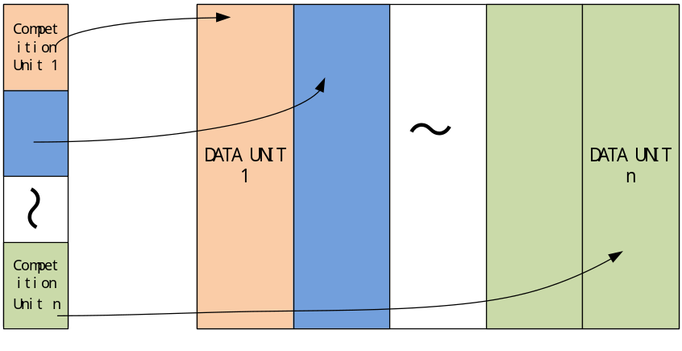
Fig4. Competition scheme for selecting timely orthogonal data unit
When multiple UEs transmit signal in one competition unit, the conflict can be solved by mechanism similar as LAA and WiFi. Each UE transmit variable transmission windows, which can be in different number and durations to other UEs. When UE is not in its transmission window, it monitors the potential transmission of other UEs. The detail of competition procedure can be further decided.
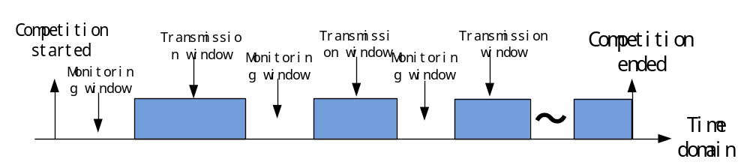
Fig. 5 transmission and monitoring windows on competition unit
Proposal 3: V2V can consider competitive resource to select timely orthogonal data unit.

Semi-persistent scheduling from eNB for PC5 transmissions
In V2V communication, for periodic traffic, the traffic data always generates in periods and the packet size may keep the same. Even for Event-triggered traffic, the messages are generated in periods and maintain some periods of time. Within network coverage, semi-persistent scheduling is a better way of resource allocation for those cases. It saves costs of assignment information of eNB and mitigates the interference and resource collision.
An example of semi-persistent scheduling is shown in Fig 4. Once eNB assign some resources to one UE, the UE may continue use the same resource in every period, until the SPS has ended. For V2V communication, it is necessary for enhancing SPS mechanism taking into consideration the periods of SA and typical packet size.
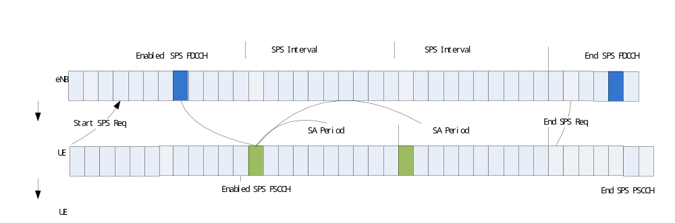
Fig. 6 an example of SPS
Proposal 4: RAN1 introduce SPS scheduling for V2V. The period of V2V SPS must be multiple of period of V2V. SCI content should be redefined for V2V SPS.

Cross-carrier scheduling
SID in RP-151109 listed [2]:
The study should cover LTE-based V2X both with and without LTE network coverage, and cover both the operating scenario where the carrier(s) is/are dedicated to LTE-based V2X services (subject to regional regulation and operator policy including the possibility of being shared by multiple operators) and the operating scenario where the carrier(s) is/are licensed spectrum and also used for normal LTE operation.
For 6GHz, the carrier is mainly dedicated to LTE-based V2X services, and may be shared by multiply operators. And for 2GHz, the carrier is licensed spectrum and also used for normal LTE operation. Considering the V2X traffic messages size (around 300 Bytes or 800 Bytes), V2V services may impose high overhead on the 2GHz carrier which is precious for LTE. The resource allocation schemes can be compacted for eNB sends control via 2GHz carrier to schedule V2X resources on 6GHz carrier.
A vehicle UE may be a subscribe user of an operator only. When there a resource pool on 6GHz dedicated for an operator, eNB send grant signal to UE on 2GHz carrier and indicate UE to use the resources on 6GHz. When the resource pool on 6GHz is shared by multiple operators, the eNBs on 2GHz carrier should changes the resource allocation information with each other, to avoid resource collision on 6GHz between different operators.
Proposal 5: Carrier indicator should be included in V2X DCI content to support cross-carrier scheduling.

Simulation results
The system simulation results are given for V2V evaluation regarding the performance of UE resource selection/allocation with collision avoidance compared to random resource allocation.
Option 1: Resource selection/allocation with collision avoidance
The avoidance can be based on certain schemes, such as competitive resource, SA retransmitting and detecting listed above. V2V UEs use time orthogonal resources within certain range. Out of that range, resources can be reused. For case1，the range of distance is 320m, and for case 2, the distance is 150m.
Option 2: Resource selection/allocation without collision avoidance and coordination
V2V UEs randomly select resources in the SCI period.

The simulation of two options as follows:
Case 1: freeway scenario, vehicle max absolute speed is 140km/h.
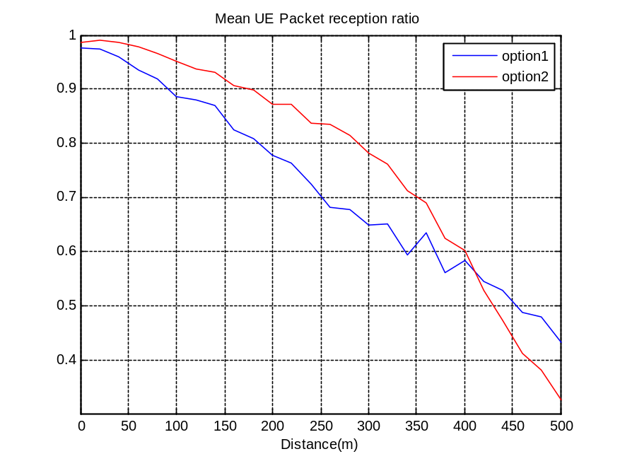
Fig. 7 PRR comparison of 2 resource allocation schemes in freeway, 140km/h
Case 2: Urban scenario, vehicle max absolute speed is 60km/h.
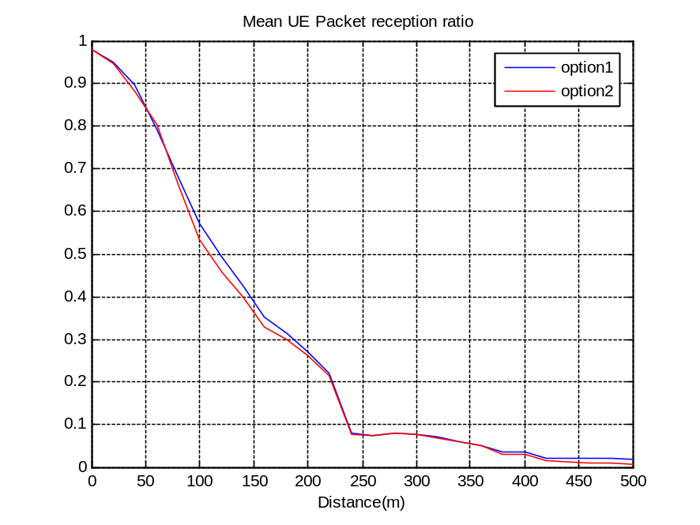
Fig. 8 PRR comparison of 2 resource allocation schemes in urban, 60km/h
It can be observed that the PRR performance of resource selection/allocation with collision avoidance achieve gain. When V2V UEs use time orthogonal resources within certain range of option1, the gain of performance would mainly come from the resource collision avoidance and mitigation on near-far effect due to inband emission.

Conclusions
In this contribution, we bring up the following proposals:
Proposal 1: SA retransmitting and SA detecting can be used for Collision avoidance.
Proposal 2: Transmitter-specific information can be used to resource selection, and the detailed parameters are needed to be identified.
Proposal 3: V2V can consider competitive resource to select timely orthogonal data unit.
Proposal 4: RAN1 introduce SPS scheduling for V2V. The period of V2V SPS must be multiple of period of V2V. SCI content should be redefined for V2V SPS.
Proposal 5: Carrier indicator should be included in V2X DCI content to support cross-carrier scheduling.

References
- R1-155232, “Resource allocation for V2V”,ZTE
- RP-151109, “Feasibility study on LTE-based V2X services”, 3GPP, June, 2015.
- R1-155411, “TP for TR 36 885 evaluation assumption”, 3GPP

appendix
The detail simulation assumptions are provided in Table 1.
Table 1: simulation assumptions
Simulation Parameters | Value
Deployment scenario | Freeway and urban as defined in [3]
Carrier frequency | 5.9GHz
System bandwidth | 10MHz
Tx Power | 23dBm
Antenna gain | 3dBi
Traffic Model | periodic traffic with 100ms period
Synchronization | Ideal
Carrier Frequency Offset | Ideal
Vehicle velocity | 140km/h for freeway, 60km/h for urban
Pathloss model | As defined in [3]
Shadowing fading | As defined in [3]
Vehicle density | defined in [3]
Resource selection method | Resource selection/allocation with collision avoidance vs. Without collision avoidance and coordination.
Modulation and coding scheme | Data transmission :  QPSK, Turbo coding, coding rate is 0.16/0.25(respectively for 190Byte and 300Byte, assuming 4 DMRS symbols)
IBE model | {3,6,3,3}
Thermal noise level | –174 dBm/Hz

